Name:__________________________ Date:_________

Homework sheet: Alg2H
Relations, Functions, Domain and Range

- Given the equation
$y=|x-1|$ ,
complete the below table, graph, domain and range, and whether the equation describes a function.

x | y

Domain:_______________

Range:_________________

Function:_______________

- Given the equation
$y=-2+\sqrt{16-x^{2}}$ ,
complete the below table, graph, domain and range, and whether the equation describes a function.

x | y

Domain:_______________

Range:_________________

Function:_______________
- Given the equation
$h(t)=200+96⋅t-16⋅t^{2}$ ,
and the Domain
$$t∈\left[0,8\right]$$

complete the below table, graph, range, and whether the equation describes a function.

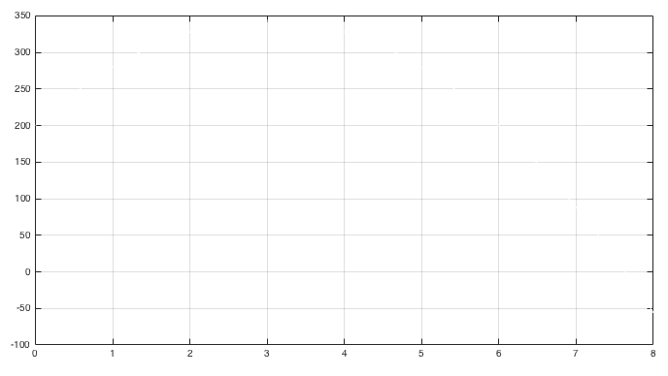
t | H

Domain:___$t∈\left[0,8\right]$___

Range:_________________

Function:_______________

==== End ====

